228 Words.
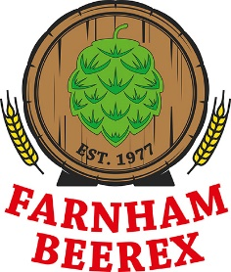
The Farnham Beerex 2017
The 41st Farnham Beerex will once again take place at the Farnham Maltings thus confirming it’s claim as the longest running ‘real ale festival’ to be held at the same venue. There will be four sessions starting on Thursday, April 27th at 6pm – 11pm. Friday 28th 6pm -11pm and Saturday 29th 11am – 3pm and 6pm -11pm. Entrants must be aged 18 or over. Entrance is by ticket only.
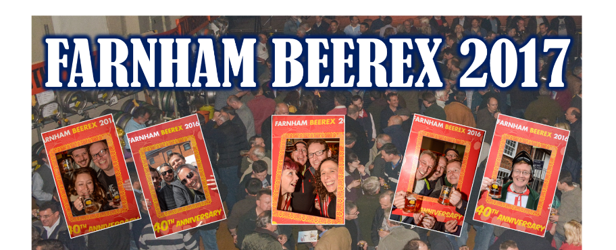
Ticket prices have been held at £10 including a souvenir glass and programme.
Tickets will be on general sale at the Maltings from 8am – 10pm, or until sold out, on Sunday March 5th. Any remaining tickets will be sold online via the ‘Farnham Lions’ website. Last year’s Friday and Saturday session tickets sold out in less than an hour.
The ‘Beer committee’ has over the last couple of months been busy selecting the 60+ ales, the ciders and perries. There will be the usual food offers and great entertainment provided by New Hawleans Jug Band on Thursday evening, by DisCover and the Gambit Jazzmen.
The ‘Farnham Beerex’ is great fun and about raising money for charity which is then distributed by the The Lions Club of Farnham to support ‘local good causes’. To date over £800,000 has been raised.
To keep up-to-date with what is happening at Beerex or to purchase tickets please visit:www.farnhamlions.org.uk/farnhambeerex or www.facebook.com/beerexfarnham

